DEGREES OF STRESS

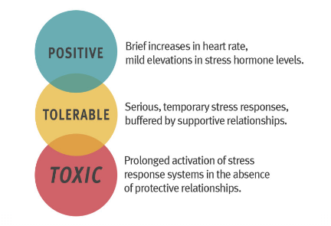

**2 TYPES OF STRESS**

**EUSTRESS Vs. DISTRESS**

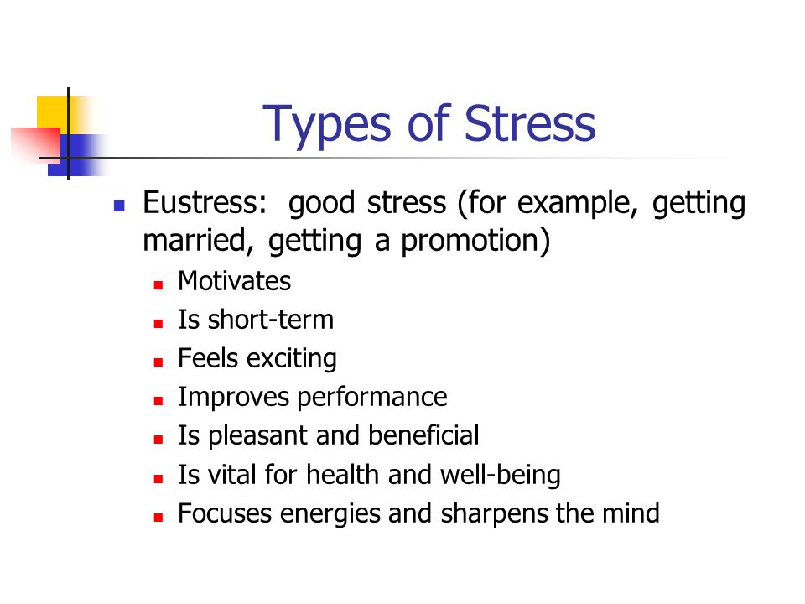

**4 CATEGORY**

Stress factors broadly fall into four types or categories: physical stress, psychological stress, psychosocial stress, and psychospiritual stress.

**Physical stress:** trauma (injury, infection, surgery), intense physical labor/over-exertion, environmental pollution (pesticides, herbicides, toxins, heavy metals, inadequate light, radiation, noise, electromagnetic fields), illness (viral, bacterial, or fungal agents), fatigue, inadequate oxygen supply, hypoglycemia I(low blood sugar), hormonal and/or biochemical imbalances, dietary stress (nutritional deficiencies, food allergies and sensitivities, unhealthy eating habits), dehydration, substance abuse, dental challenges, and musculoskeletal misalignments/imbalances.

**Psychological stress:** emotional stress (resentments, fears, frustration, sadness, anger, grief/bereavement), cognitive stress (information overload, accelerated sense of time, worry, guilt, shame, jealousy, resistance, attachments, self-criticism, self-loathing, unworkable perfectionism, anxiety, panic attacks, not feeling like yourself, not feeling like things are real, and a sense of being out of control/not being in control), and perceptual stress (beliefs, roles, stories, attitudes, world view).

**Psychosocial stress:** relationship/marriage difficulties (partner, siblings, children, family, employer, co-workers, employer), lack of social support, lack of resources for adequate survival, loss of employment/investments/savings, loss of loved ones, bankruptcy, home foreclosure, and isolation.

**Psycho-spiritual stress:** A crisis of values, meaning, and purpose; joyless striving (instead of productive, satisfying, meaningful and fulfilling work; and a misalignment within one’s core spiritual beliefs.

Overall, improperly or ineffectively managed stress usually takes a toll on the body. When stress-related feelings, moods, emotions are pushed into the body, the soma, this is usually termed psychosomatic or psychogenic illness, including headaches, heart palpitations, physical/cognitive/emotional pain and suffering, constricted throat and shallow, constricted breathing, clammy palms, fatigue, nausea, anxiety, allergies, asthma, autoimmune syndromes related to an ineffective functioning of the immune system, hypertension (high blood pressure), and gastrointestinal disturbances such as diarrhea, upset stomach, duodenal ulcers and esophageal reflux syndrome.

EFFECTS/OUTCOMES

Prolonged stress can result in suppressed immune function, increased susceptibility to infectious and immune-related diseases and cancer. Emotional stress can also result in hormonal imbalances (adrenal, pituitary, thyroid, etcetera) that further interfere with healthy immune functioning.

**Cognitive:** Anxious thoughts, fearful anticipation, poor concentration, difficulty with memory.

**Emotional:** Feelings of tension, irritability, restlessness, worries, inability to relax, depression.

**Behavioral:** Avoidance of tasks; sleep problems; difficulty in completing work assignments; fidgeting; tremors; strained face; clenching fists; crying; changes in drinking, eating, or smoking behaviors.

**Physiological:** Stiff or tense muscles, grinding teeth, sweating, tension headaches, faint feelings, choking feeling, difficulty in swallowing, stomachache, nausea, vomiting, loosening of bowels, constipation, frequency and urgency of urination, loss of interest in sex, tiredness, shakiness or tremors, weight loss or gain, awareness of heart beat.

**Social:** Some people in stressful times tend to seek out others to be with. Other people withdraw under stress. Also, the quality of relationships can change when a person is under stress.

CAUSES

